H.T No
Regulations:
A19

Sreenidhi Institute of Science and Technology
(An Autonomous Institution)
Code No: 7R101 Date: 27-April-2022 (FN)

M.Tech I-Year I-Semester External Examination, April/May - 2022 (Regular/Supplementary)
ADVANCED DATA STRUCTURES (CNIS)

Time: 3 Hours Max.Marks:70

Note: a) No additional answer sheets will be provided.
b) All sub-parts of a question must be answered at one place only, otherwise it will not be valued.
c) Missing data can be assumed suitably.

ANSWER ANY FIVE QUESTIONS. EACH QUESTION CARRIES 14 MARKS.

Bloom's Cognitive Levels of Learning (BCLL)
Remember | L1 | Apply | L3 | Evaluate | L5
Understand | L2 | Analyze | L4 | Create | L6

 |  |  | BCLL | CO(s) | Marks
1. | a) | Compare and contrast various Asymptotic notations and explain with examples. | L4 | CO1 | [7M]
 | b) | Write the algorithm for matrix addition and derive space complexity. | L3 | CO1 | [7M]
2. | a) | How to perform insertion operation at beginning ,end and middle of a single linked list explain with example. | L3 | CO2 | [7M]
 | b) | Explain stack ADT using linked list? | L3 | CO2 | [7M]
3. | a) | Examine adjacency and path matrix representation of graphs with example. | L4 | CO3 | [7M]
 | b) | Discuss the process of realizing a priority queue using heap with an example. | L4 | CO3 | [7M]
4. | a) | Compare and contrast iterative merge sort with recursive merge sort. | L4 | CO4 | [7M]
 | b) | Sort the following list of elements using quick sort algorithm 10,25,32,12,5,46,89,23,45 | L3 | CO4 | [7M]
5. | a) | Write the algorithm for Prim’s Minimal Spanning tree. | L1 | CO5 | [7M]
 | b) | Construct MST for the following graph using Prim’s Algorithm.  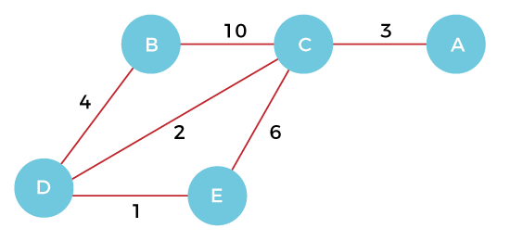 | L3 | CO5 | [7M]
6. | a) | What is traveling sales person problem? Explain how it is solved using Dynamic programming. | L3 | CO6 | [7M]
 | b) | Describe the Dynamic 0/1 Knapsack Problem. Find an optimal solution for the dynamic programming 0/1 knapsack instance for n=3, m=6, profits are  (p1, p2, p3 ) = (1,2,5), weights are (w1,w2,w3)=(2,3,4). | L3 | CO6 | [7M]
7. | a) | Define ADT and explain how they are helpful in implementing data structures. | L2 | CO1 | [5M]
 | b) | Explain Postfix notation with an example. | L2 | CO2 | [5M]
 | c) | Differentiate linear and non liner data structures. | L4 | CO3 | [4M]
8. | a) | Summarize the algorithm for bubble sort. | L2 | CO4 | [5M]
 | b) | Interpret the general method/algorithm of Greedy method. | L2 | CO5 | [5M]
 | c) | Write the general method/algorithm of dynamic programming. | L1 | CO6 | [4M]

-- 00 -- 00 –

